SSH commands

To log in to an SSH server using a private key for authentication, you'll typically use the `ssh` command along with the `-i` flag to specify the path to your private key file. Here's the general syntax:

```bash
ssh -i /path/to/private_key username@remote_host
```
eg:
ssh -i /home/janarth/Downloads/bala.ppk username server@ip addresss

Replace `/path/to/private_key` with the actual path to your private key file, `username` with your username on the remote server, and `remote_host` with the server's IP address or domain name.

For example, if your private key is located in `~/.ssh/id_rsa` and you want to connect as user `myuser` to a server with IP `123.456.78.9`, the command would look like this:

```bash
ssh -i ~/.ssh/id_rsa myuser@123.456.78.9
```
Make sure the permissions on your private key file (`id_rsa` or any other key) are secure. SSH may refuse to use the key if it's accessible by others. Set the appropriate permissions:

```bash
chmod 600 ~/.ssh/id_rsa
```

This command sets the permissions so that only the owner has read and write access to the private key.

Remember, the public key associated with your private key must be added to the `~/.ssh/authorized_keys` file on the remote server to authenticate successfully. If the public key isn't added, the SSH server won't recognize your private key for authentication.

Create own ssh on system

To generate an SSH key pair on a Linux system, you can use the ssh-keygen command. Here's a step-by-step guide:
- Open a Terminal: Open a terminal window on your Linux machine.
- Generate SSH Key: Use the ssh-keygen command to generate an SSH key pair:
bash Copy code
ssh-keygen -t rsa -b 4096 -C "jakejana019@gmail.com"
Replace your_email@example.com with your email address. This command creates a 4096-bit RSA key pair, but you can adjust the -b parameter for a different key size.
- -t rsa: Specifies the RSA key type.
- -b 4096: Sets the key length to 4096 bits.
- -C "jakejana019@gmail.com": Sets the comment or label for the key to the specified email address for identification purposes.
- Enter File to Save Key: The terminal will prompt you to enter a file to save the key pair. Press Enter to save the key pair in the default location (~/.ssh/id_rsa), or specify a different path.
- Set Passphrase (Optional): You can set a passphrase for extra security. Press Enter to skip or enter a passphrase and confirm.

Viewing and Using SSH Keys:
Once created, you can view your SSH keys:
- Public Key: To display the public key:
bash Copy code
cat ~/.ssh/id_rsa.pub
- Private Key: Keep the private key (~/.ssh/id_rsa) secure and do not share it. It's used for authentication.

Adding SSH Key to SSH Agent:
To use the newly generated SSH key, add it to the SSH agent:
bash Copy code
ssh-add ~/.ssh/id_rsa
This process generates an SSH key pair and adds it to the SSH agent for secure authentication. The public key (id_rsa.pub) can be shared with services like GitHub, GitLab, or servers where you want to use SSH authentication.

Find commands

In Linux, the `find` command is used to search for files and directories within a specified directory hierarchy. It's a powerful tool that allows various search criteria to be specified. Here are some examples:

### Basic Usage:

1. **Finding a File by Name:**
```bash
find /path/to/directory -name "filename"
```
This command searches for a file named "filename" within the specified directory.

2. **Finding Files by Extension:**
```bash
find /path/to/directory -name "*.extension"
```
Replace `extension` with the specific file extension (e.g., `*.txt`, `*.pdf`, etc.).

### Searching by Modification Time:

3. **Finding Files Modified in the Last 'n' Days:**
```bash
find /path/to/directory -mtime -n
```
Replace `n` with the number of days. This command finds files modified within the last 'n' days.

4. **Finding Files Modified Exactly 'n' Days Ago:**
```bash
find /path/to/directory -mtime n
```
This command finds files modified exactly 'n' days ago.

### Search with File Size:

5. **Finding Files by Size (Greater Than):**
```bash
find /path/to/directory -size +n[ckMG]
```
Replace `n` with the file size, and `ckMG` specifies units (c: bytes, k: kilobytes, M: megabytes, G: gigabytes).

6. **Finding Files by Size (Less Than):**
```bash
find /path/to/directory -size -n[ckMG]
```
This command finds files smaller than the specified size.

### Additional Options:

- **Searching Only in Directories (Exclude Files):**
```bash
find /path/to/directory -type d -name "dirname"
```
This command searches for directories named "dirname."

- **Searching for Empty Files or Directories:**
```bash
find /path/to/directory -empty
```
This command finds empty files or directories within the specified directory.

These examples demonstrate how the `find` command can be used to search for files and directories based on different criteria like name, modification time, size, type, and more. Adjust the commands according to your specific search requirements.

Git installation and git all commands

To interact with GitHub from the command line in Linux, you'll want to install Git, which is a version control system used to manage and track changes in code repositories, including those hosted on GitHub. Here are the steps to install Git and some basic commands:

### Installing Git:

1. **Update Package Lists:**
```bash
sudo apt update
```

2. **Install Git:**
```bash
sudo apt install git
```

### Basic Git Commands:

1. **Configure Git:**
- Set your username:
```bash
git config --global user.name "Your Name"
```
- Set your email:
```bash
git config --global user.email "your_email@example.com"
```

2. **Clone a Repository:**
```bash
git clone repository_URL
```
Replace `repository_URL` with the URL of the GitHub repository you want to clone.

3. **Add Changes:**
- Add all changes in the current directory to the staging area:
```bash
git add .
```

4. **Commit Changes:**
- Commit staged changes with a message:
```bash
git commit -m "Commit message"
```

5. **Push Changes to Remote Repository:**
- Push committed changes to the remote repository:
```bash
git push origin branch_name
```
Replace `branch_name` with the name of the branch you want to push.

6. **Pull Changes from Remote Repository:**
- Fetch and merge changes from the remote repository:
```bash
git pull origin branch_name
```
Replace `branch_name` with the name of the branch you want to pull changes from.

7. **Check Status:**
- Check the status of the working directory:
```bash
git status
```

git config
- git init
- git clone
- git add
- git commit
- git diff
- git reset
- git status
- git rm
- git log
- git show
- git tag
- git branch
- git checkout
- git merge
- git remote
- git push
- git pull
- git stash
So, let's get started!
Related: Gitlab CI/CD Tutorial.

Git Commands

git config
Usage: git config –global user.name “[name]”
Usage: git config –global user.email “[email address]”
This command sets the author name and email address respectively to be used with your commits.

git init
Usage: git init [repository name]

This command is used to start a new repository.

git clone
Usage: git clone [url]
This command is used to obtain a repository from an existing URL.
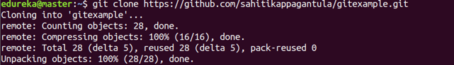

git add
Usage: git add [file]
This command adds a file to the staging area.
Usage: git add *
This command adds one or more to the staging area.

git commit
Usage: git commit -m “[ Type in the commit message]”
This command records or snapshots the file permanently in the version history.
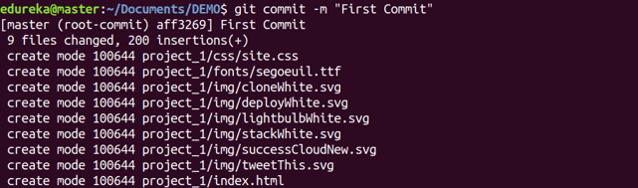
Usage: git commit -a
This command commits any files you’ve added with the git add command and also commits any files you’ve changed since then.

git diff
Usage: git diff
This command shows the file differences which are not yet staged.
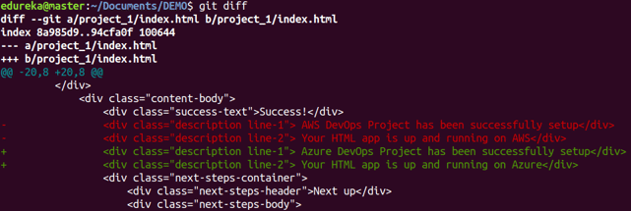
Usage: git diff –staged
This command shows the differences between the files in the staging area and the latest version present.
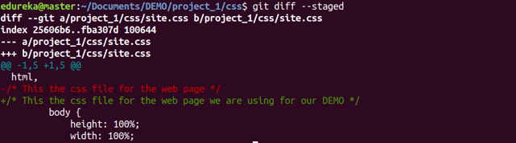
Usage: git diff [first branch] [second branch]
This command shows the differences between the two branches mentioned.
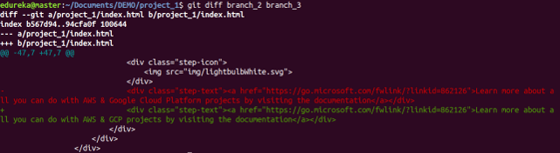

git reset
Usage: git reset [file]
This command unstages the file, but it preserves the file contents.
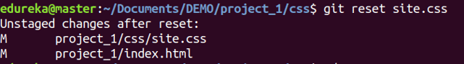
Usage: git reset [commit]
This command undoes all the commits after the specified commit and preserves the changes locally.
Usage: git reset –hard [commit] This command discards all history and goes back to the specified commit.
Learn how to connect Git secrets with a Jenkins pipeline.

git status
Usage: git status
This command lists all the files that have to be committed.
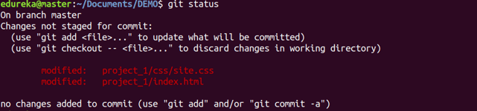

git rm
Usage: git rm [file]
This command deletes the file from your working directory and stages the deletion.

git log
Usage: git log
This command is used to list the version history for the current branch.
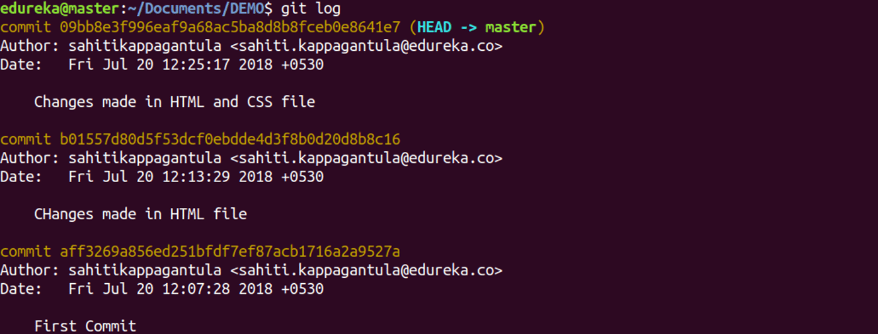
Usage: git log –follow[file]
This command lists version history for a file, including the renaming of files also.
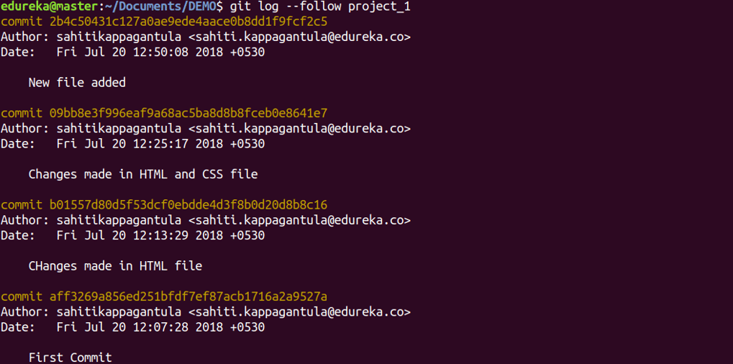

git show
Usage: git show [commit]
This command shows the metadata and content changes of the specified commit.
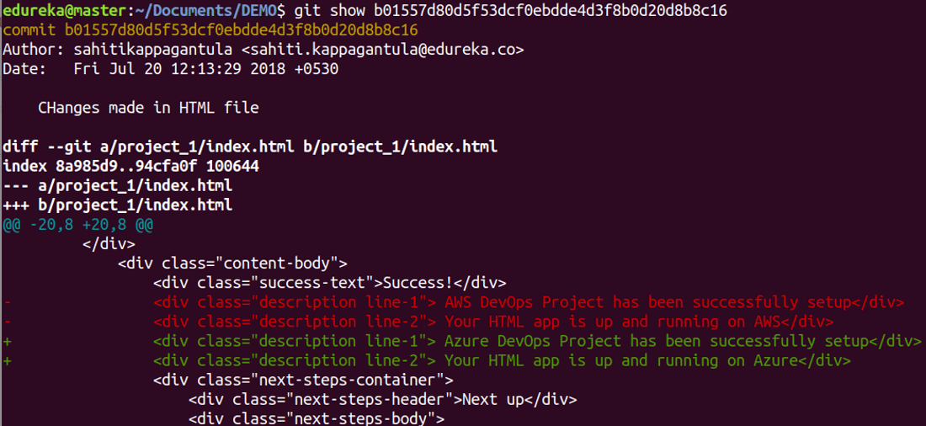

git tag
Usage: git tag [commitID]
This command is used to give tags to the specified commit.
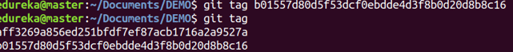

git branch
Usage: git branch
This command lists all the local branches in the current repository.
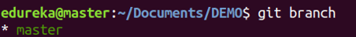
Usage: git branch [branch name]
This command creates a new branch.
Usage: git branch -d [branch name]
This command deletes the feature branch.

git checkout
Usage: git checkout [branch name]
This command is used to switch from one branch to another.
Usage: git checkout -b [branch name]
This command creates a new branch and also switches to it.

git merge
Usage: git merge [branch name]
This command merges the specified branch’s history into the current branch.
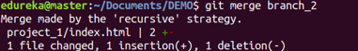

git remote
Usage: git remote add [variable name] [Remote Server Link]
This command is used to connect your local repository to the remote server.

git push
Usage: git push [variable name] master
This command sends the committed changes of master branch to your remote repository.
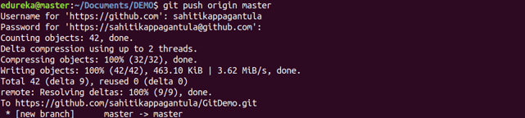
Usage: git push [variable name] [branch]
This command sends the branch commits to your remote repository.
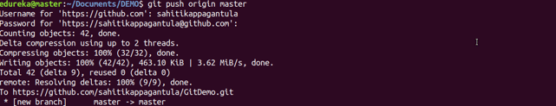
Usage: git push –all [variable name]
This command pushes all branches to your remote repository.
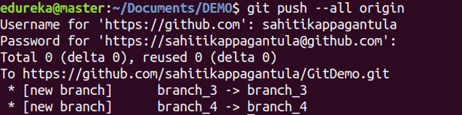
Usage: git push [variable name] :[branch name]
This command deletes a branch on your remote repository.
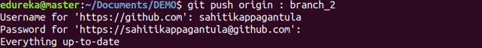

git pull
Usage: git pull [Repository Link]
This command fetches and merges changes on the remote server to your working directory.
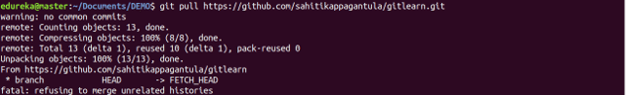
Related Guide: Jenkins VS Gitlab

git stash
Usage: git stash save
This command temporarily stores all the modified tracked files.
Usage: git stash pop
This command restores the most recently stashed files.
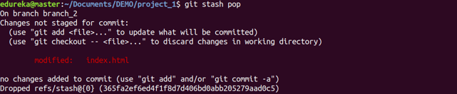
Usage: git stash list
This command lists all stashed changesets.
Usage: git stash drop
This command discards the most recently stashed changeset.

These are some fundamental commands to interact with Git repositories hosted on GitHub. Adjust the commands based on your specific workflow and repository needs.

Set commands
The set command in Linux is a built-in shell command used to set or change the environment for the current shell session or to display shell options and positional parameters.

Common Uses of the set Command:
- Setting Shell Options:
  - Change shell behavior by setting various options.
bashCopy code
set -o option_name
Replace option_name with specific options like errexit, nounset, noclobber, etc.
- Setting Positional Parameters:
  - Set positional parameters manually for use within a script or shell session.
bashCopy code
set param1 param2 param3
- Displaying Shell Options:
  - View the current shell options and their statuses.
bashCopy code
set -o
- Displaying Positional Parameters:
  - View the current values of positional parameters set within a script or shell session.
bashCopy code
echo $1 $2 $3 ...
Or to see all at once:
bashCopy code
echo $@
- Unsetting Options:
  - Unset previously set options to revert to default behavior.
bashCopy code
set +o option_name
- Setting Default Values for Undefined Variables:
  - Set a default value for undefined variables.
bashCopy code
${VAR:-default_value}

Notes:
- Some options, when set, change the behavior of the shell.
- Positional parameters ($1, $2, etc.) refer to command-line arguments passed to a script or shell function.
The set command is versatile and used mainly for setting shell options, handling positional parameters, and managing the shell's behavior within scripts or interactive shell sessions. Always refer to the specific shell's documentation for more detailed information on available options and their usage.

Example: Creating Files and Using set in a Script:
Let's create a simple shell script that sets some shell options and creates example files:
- Create a Shell Script: Open a text editor and create a file named create_files.sh.
- Script Content: Add the following content to create_files.sh:
bashCopy code
#!/bin/bash

# Set options: Exit on error, display all commands.
set -e
set -x

# Create example files
touch file1.txt
touch file2.txt

# Show shell options
echo "Shell Options:"
set -o

# Display positional parameters
echo "Positional Parameters:"
echo "Param 1: $1"
echo "Param 2: $2"
- Save and Make Script Executable: Save the script, and in a terminal, make it executable:
bashCopy code
chmod +x create_files.sh
- Run the Script: Execute the script with optional parameters:
bashCopy code
./create_files.sh arg1 arg2
Replace arg1 and arg2 with any arguments you want to pass to the script.
This script sets the shell options to exit on error (-e) and display all commands (-x). Then, it creates two example files (file1.txt and file2.txt), displays the current shell options (set -o), and shows any positional parameters passed to the script.
Feel free to modify the script to suit your specific needs or to create more complex scenarios involving file creation and shell options.

Linux set Command Syntax
The general syntax for the set command is:
set [options] [arguments]
Options
In the context of the set command, [options] are settings or flags that are set or unset in the Bash shell environment. Use it to influence the behavior of defined shell scripts and help execute the desired tasks.
- Set an option by using a minus sign (-) followed by the appropriate option.
- Unset an option by using a plus sign (+) followed by the appropriate option.
Arguments
[arguments] are positional parameters and they are assigned in order with the following parameters:
- $1
- $2
- ...
- $n
Not specifying any options or arguments causes the command to print all shell variables.
Exit Values
The set command has three exit values:
- 0. Marks a successful completion.
- 1. Failure caused by an invalid argument.
- 2. Failure resulting in a usage message, usually because an argument is missing.

Linux set Command Options
The set command provides an extensive list of options that can be combined.
Most options have a corresponding -o flag that can be used to invoke the option. The table below lists all options and their respective alternative form using the -o flag syntax.
Options | -o flags | Description
-a | -o allexport | Marks all created or modified variables or functions for export.
-b | -o notify | Alerts the user upon background job termination.
-e | -o errexit | Instructs a shell to exit if a command fails, i.e., if it outputs a non-zero exit status.
-f | -o noglob | Disables filename generation (globbing).
-h | -o hashall | Locates and saves function commands when a function is defined. The -h option is enabled by default.
-k | -o keyword | Places all assignment arguments in the environment for a command, not just those preceding the command name.
-n | -o noexec | Reads commands but doesn't execute them.
-m | -o monitor | Displays a message when a task completes.
-p | -o privileged | Disables the $ENV file processing and shell functions importing. The -p option is enabled by default when the real and effective user IDs don't match. Turning it off sets the effective uid and gid to the real uid and gid.
-t | -o onecmd | Reads one command and then exits.
-u | -o nounset | Treats unset or undefined variables as an error when substituting (during parameter expansion). Does not apply to special parameters such as wildcard * or @.
-v | -o verbose | Prints out shell input lines while reading them.
-x | -o xtrace | Prints out command arguments during execution.
-B | -o braceexpand | Performs shell brace expansion.
-C | -o noclobber | Prevents overwriting existing regular files by output redirection. By default, Bash allows redirected output to overwrite existing files.
-E | -o errtrace | Causes shell functions to inherit the ERR trap.
-H | -o histexpand | Enables style history substitution. The option is on by default when the shell is interactive.
-P | -o physical | Prevents symbolic link following when executing commands.
-T | -o functrace | Causes shell functions to inherit the DEBUG trap.
-- | n/a | Assigns the remaining arguments to the positional parameters. If there are no remaining arguments, unsets the positional parameters.
- | n/a | Assigns any remaining arguments to the positional parameters. Turns off the -x and -v options.
n/a | -o emacs | Uses and emacs-style line editing interface.
n/a | -o history | Enables command history.
n/a | -o ignoreeof | The shell doesn't quit upon reading the end of file.
n/a | -o interactive-comments | Allows comments in interactive commands.
n/a | -o nolog | Does not record function definitions in the history file.
n/a | -o pipefail | The return value of a pipeline is the status of the last command that had a non-zero status upon exit. If no command had a non-zero status upon exit, the value is zero.
n/a | -o posix | Causes Bash to match the standard when the default operation differs from the Posix standard.
n/a | -o vi | Uses a line editing interface similar to vi.

Linux set Command Examples
This section lists examples of the most common uses of the set command.

Using the set Command Without Options
Running the command without options or arguments outputs a list of all settings - the names and values of all shell variables and functions. Since the list is very long, you can scroll through it using the Page Up and Page Down keys.
Following is an example of a partial set command output:
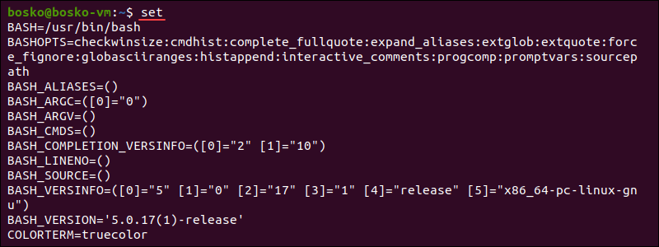

Script Debugging
The set command is especially handy when you are trying to debug your scripts. Use the -x option with the set command to see which command in your script is being executed after the result, allowing you to determine each command's result.
The following example demonstrates how to debug scripts with set -x. Follow the steps below:
1. Run set -x:
set -x
2. Use your favorite text editor (we use the vi editor) to create a script. We created a simple loop that allows us to see the -x option effects:
x=10
while [ $x -gt 0 ]; do
x=$[ $x-1 ]
echo $x
sleep 2
done
3. Make sure to chmod the script to make it executable. This step is always mandatory before running a script. The syntax is:
chmod +x [script-name.sh]
4. Execute the script. The syntax is:
./[script-name.sh]
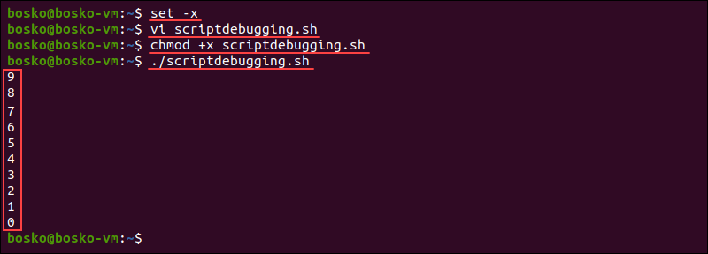
The output prints one line at a time, runs it, shows the result if there is one, and moves on to the next line.
Another way to enable debugging is to place the -x flag on the shebang line of the script:
#!/bin/bash -x

Script Exporting
Automatically export any variable or function created using the -a option. Exporting variables or functions allows other subshells and scripts to use them.
Enable script exporting by running the following command:
set -a
The following example shows how script exporting works. Follow the steps below:
1. Create a new script using your editor of choice. For example:
one=1
two=2
three=3
four=4
/bin/bash
The /bin/bash argument marks the start of a new shell.
2. Check if the script works in a new shell:
echo $one $two $three $four
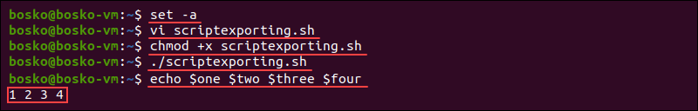
The output proves that the function we created was exported and works even when starting a new shell.

Exit When a Command Fails
Use the -e option to instruct a script to exit if it encounters an error during execution. Stopping a partially functional script helps prevent issues or incorrect results.
Create a script with the following contents to test this option:
#!/bin/bash
set -e
cat nonexistingfile
echo "The end"
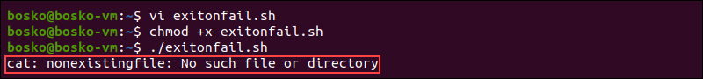
In the example above, the script encounters an error when trying to show the contents of nonexistingfile because that file doesn't exist, causing it to exit at that point. Thus, the final echo command isn't executed.

Prevent Data Loss
The default Bash setting is to overwrite existing files. However, using the -C option configures Bash not to overwrite an existing file when output redirection using >, >&, or <> is redirected to that file.
For example:
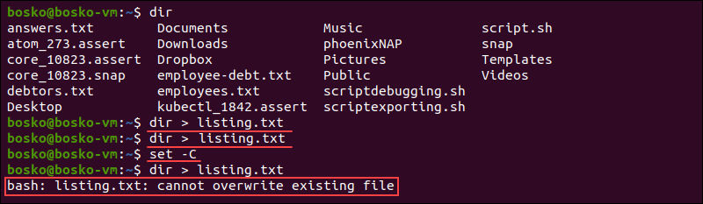
Bash first allows us to overwrite the listing.txt file. However, after running the set -C command, Bash outputs a message stating that it cannot overwrite an existing file.

Report Non-Existent Variables
The default setting in Bash is to ignore non-existent variables and work with existing ones. Using the -u option prevents Bash from ignoring variables that don't exist and makes it report the issue.
For example, the following script doesn't contain the set -u command and Bash ignores that $var2 isn't defined.
#!/bin/bash
var1="123"
echo $var1 $var2
The output contains only $var1.
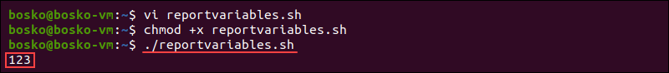
However, changing the script and adding the set -u command prevents Bash from ignoring the problem and reports it:
#!/bin/bash
set -u
var1="123"
echo $var1 $var2

Set Positional Parameters
The set command can also assign values to positional parameters. A positional parameter is a shell variable whose value is referenced using the following syntax:
$[N]
The [N] value is a digit that denotes the position of the parameter. For example, $1 is the first positional parameter, $2 is the second parameter, etc.
For example:
set first second third
Running the command above sets first to correspond to the $1 positional parameter, second to $2, and third to $3. Check this with the echo command:
echo $2
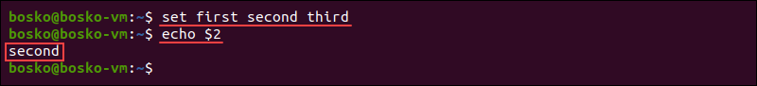
Unset positional parameters by running:
set --

Split Strings
Use the set command to split strings based on spaces into separate variables. For example, split the strings in a variable called myvar, which says "This is a test".
myvar="This is a test"

set -- $myvar
echo $1
echo $2
echo $3
echo $4

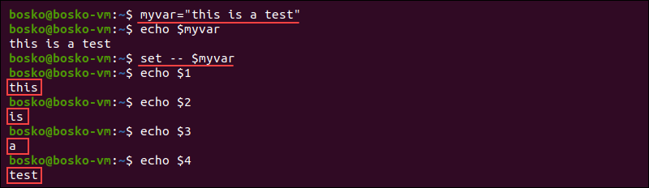
Use this option to extract and filter out information from the output of a command, similar to what the awk command does.

Set allexport and notify Flags
The -o allexport flag allows you to automatically export all subsequently defined variables, while the -o notify flag instructs the shell to print job completion messages right away.
To set the flags, run:
set -o allexport -o notify
In the following example, we see that the shell notifies you upon background job completion since the script was exported:
